**Figure 2.1: SHS students’ perception of purpose in schooling by sex**

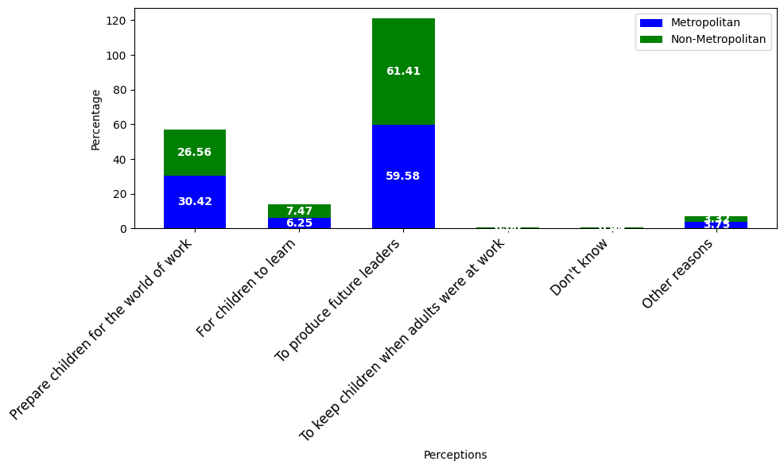

**Figure 2.1: SHS students’ perception of purpose in schooling by Metropolitan status**

**Figure 2.1: SHS students’ perception of purpose in schooling by Ecological zones.**

**Figure 2.2: Perception of SHS students on the school environment by sex**

**Figure 2.2: Perception of SHS students on the school environment by sex**

**Figure 2.2: Perception of SHS students on the school environment by zone**